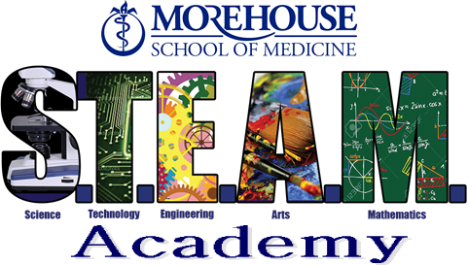

- Applications MUST be postmarked by deadline date:

- Fall-September 15
- Spring-January 15
- Summer-April 1

- Applications should be complete upon submission. Incomplete applications will not be reviewed

- Returning students are considered with priority

- Early submission is encouraged for new and returning applicants

- Applicants will be notified of acceptance by mail or email

- New students are required to submit a one page essay
  - Elementary students are required to submit a handwritten or typed essay
    - Topic: Why I want to participate in the Ben Carson Science Academy (4th & 5th Graders)
  - Middle school students are required to submit a typed essay, double spaced in Times New Roman 12 point font with 1”margins on each side.
    - Topic: Why it is important to be scientifically literate in today’s society (6th, 7th, & 8th Graders)

Selection Criteria: The following criteria will be used in selecting students to participate in the Benjamin Carson Science Academy

NEW STUDENTS
The student must:
- Have a minimum of a “B” average in academic coursework
- Have a minimum of a “B” average math or science
- Be a candidate for promotion to the next grade level
- Have regular in school attendance
- Have demonstrated academic potential
- Have an aptitude and interest in science
- Complete new student application by the application deadline
- Submit two letters of recommendations from educational officials from the home school (one must be from a science teacher)
- Submit a one page essay
- Submit a copy of the most recent report card and achievement test scores

RETURNING STUDENTS
The student must:
- Have been accepted and attended a previous Saturday or Summer Science Academy
- Have maintained the minimum required grade point average
- Be a candidate for promotion to the next grade level
- Have regular in school attendance
- Have demonstrated academic potential
- Have an aptitude and interest in science
- Complete returning student application by the application deadline
- Submit a copy of the most recent report card and achievement test scores

NEW STUDENT CHECKLIST

___Application
___Recent student photograph
___Current Report Card (demonstrating C+ average)
___Letter of recommendation from science teacher
___Letter of recommendation from guidance counselor
___One-page writing sample (see writing sample section for instructions)
___Achievement test scores (i.e. CRCT, ITBS)

RETURNING STUDENT CHECKLIST

___Returning student application
___Current Report Card (report cards from previous programs will not be used)
___Current Achievement test scores (i.e. CRCT, ITBS, Stanford)

